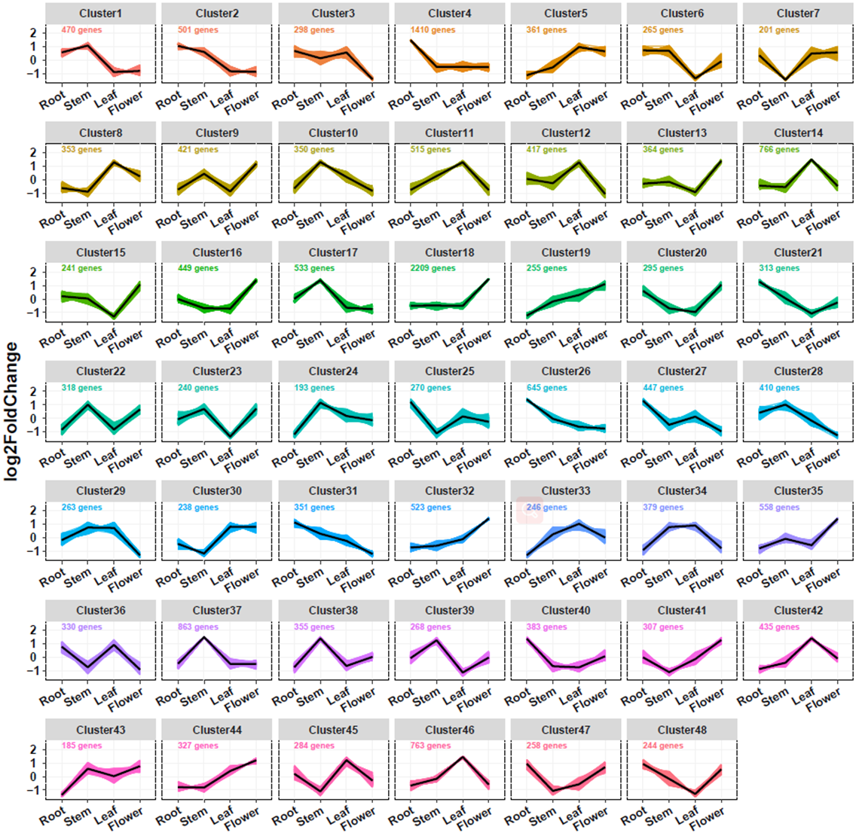

Supplementary Figure S13. All expressed genes were clustered into 48 clusters in different *S. barbata* tissues, namely, root, stem, leaf, and flower tissues, based on k-means clustering.